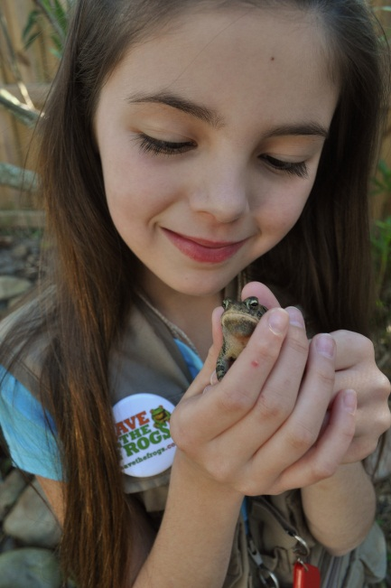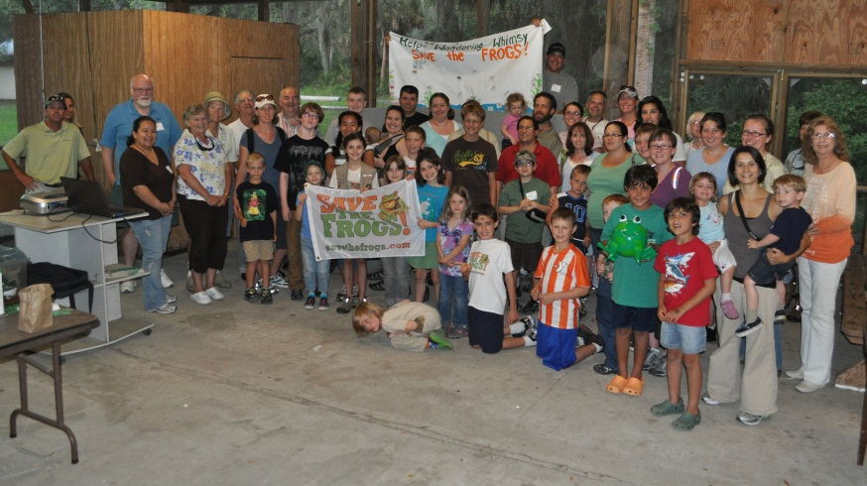

Fun with Frogs in Florida:
A Tampa Bay Area Save the Frogs Day Event

Children and adults are invited to join us for the world’s largest day of amphibian education and conservation action! Spend a fun, casual morning in a beautiful Florida setting learning about frogs and their importance to Florida and the rest of the world. This Save the Frogs Day event is Saturday, April 29 from 10am-2pm at Camp Bayou Outdoor Learning Center. Enjoy educational frog games, activities, and be part of Florida's Largest (Human) Frog Chorus ever!

Pre-registration is appreciated at www.ConserveItForward.com. A suggested donation of $5 per person will equally benefit Camp Bayou Outdoor Learning Center and Save the Frogs, America’s first and only public charity dedicated exclusively to amphibian conservation.

Contact ConserveItForward@verizon.net or (813) 469-0472 with questions. Visit www.CampBayou.org for directions.

Camp Bayou is neither a campground nor a summer camp. It was an RV park before the County's ELAP program purchased the land but it is now open for day use only, open to the general public. Through volunteers, donations, membership and grants, the RCDF offers pre-scheduled programs to schools, youth groups, adult groups and families plus it's open from Thursday- Saturday from 9am-2pm for passive recreational pursuits such as wildlife watching, nature photography and trail walks. General admission is still FREE.

The Camp Bayou Outdoor Learning Center is managed by the newly created, non-profit Bayou Outdoor Learning and Discovery, Inc. (BOLD), in a public- private partnership with the non-profit Ruskin Community Development Foundation, Inc. (RCDF) and Hillsborough County Parks, Recreation and Conservation. Camp Bayou is located 3 miles south of SR674 at the end of 24th St SE in Ruskin. More information is on the web at www.campbayou.org or call 813-641-8545.
###

